Command : sudo nmap -sU -pU:123 -Pn -n --script=ntp-monlist

Ip address : 143.244.134.254

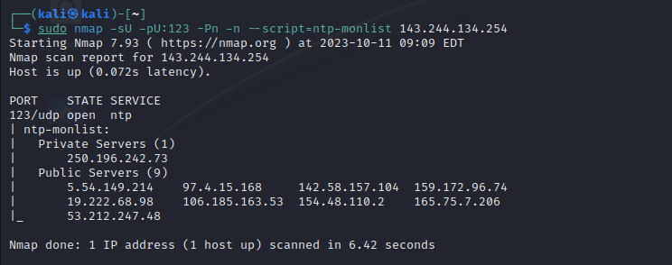

Command : sudo nmap -sU -pU:123 -Pn -n --script=ntp-monlist

Ip address : 103.123.165.134

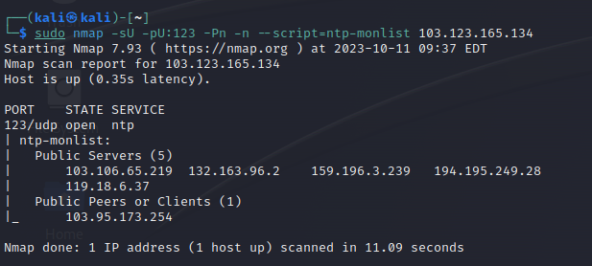

Command : sudo nmap -sU -pU:123 -Pn -n --script=ntp-monlist

Ip address : 98.73.211.30

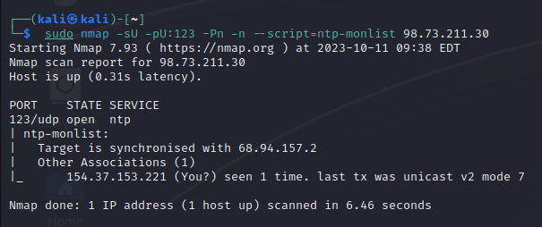

Command : sudo nmap -sU -pU:123 -Pn -n --script=ntp-monlist

Ip address : 58.13.44.179

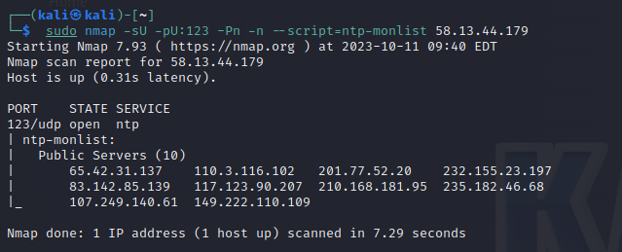

Command ; sudo nmap -sU -pU:123 -Pn -n --script=ntp-monlist

Ip address : 20.127.218.102

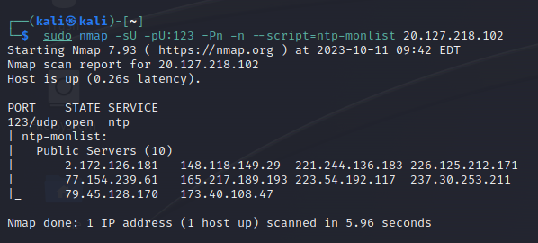

Command : sudo nmap -sU -pU:123 -Pn -n --script=ntp-monlist

Ip address : 34.147.233.138

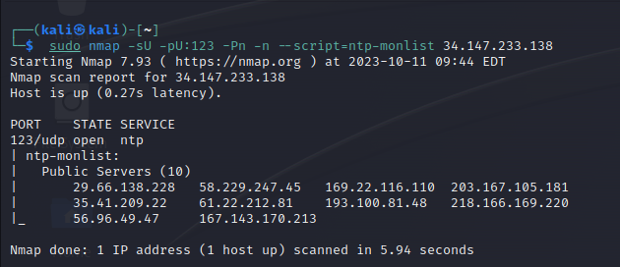

Command : sudo nmap -sU -pU:123 -Pn -n --script=ntp-monlist

Ip address : 136.163.129.10

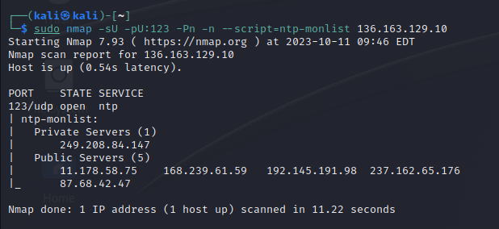

Command ; sudo nmap -sU -pU:123 -Pn -n --script=ntp-monlist

Ip address : 61.197.114.233

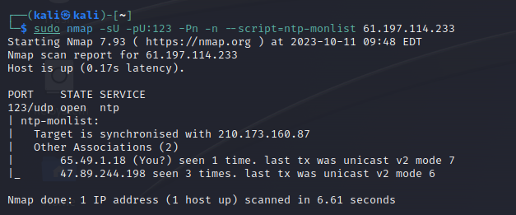

Command : sudo nmap -sU -pU:123 -Pn -n --script=ntp-monlist

Ip address : 14.139.238.141

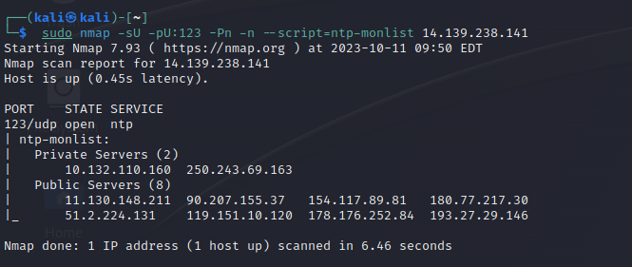

Command : sudo nmap -sU -pU:123 -Pn -n --script=ntp-monlist

Ip address : 14.194.139.163

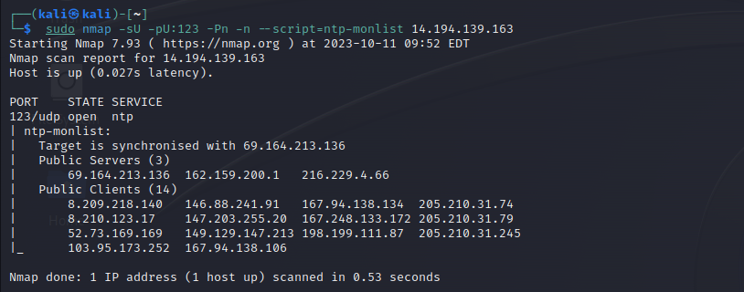

nmap -iL /home/kali/ip_list

Ip :

